O‘ZBEKISTON RESPUBLIKASI HARBIY XAVFSIZLIK VA MUDOFАA UNIVERSITETI
AXBOROT-KOMMUNIKATSIYA TEXNOLOGIYALARI VA HARBIY ALOQA INSTITUTI

Sun’iy intelekt asoslari fanidan
4-topshiriq
Mavzu: Pythonda fayllar bilan ishlash.

Bajardi: Kursant Abdurazzoqov A
Qabul qildi: Kapitan Isakov M

Toshkent-2025
4-topshiriq
2-variant
1. Ikkilik faylni o‘qish va yozish: image.png faylini ikkilik rejimda o‘qing, uning birinchi 100 baytini konsolga chiqarib bering. So‘ngra, yangi faylga (masalan, image_copy.png) nusxalashni amalga oshiring.
2. Faylga qo‘shimcha yozish: log.txt faylini oching va unga "Yangilangan ma'lumot" matnini qo‘shing. Fayldan oxirgi yozuvni o‘qing va ekranga chiqarib bering.

Javoblar
1.
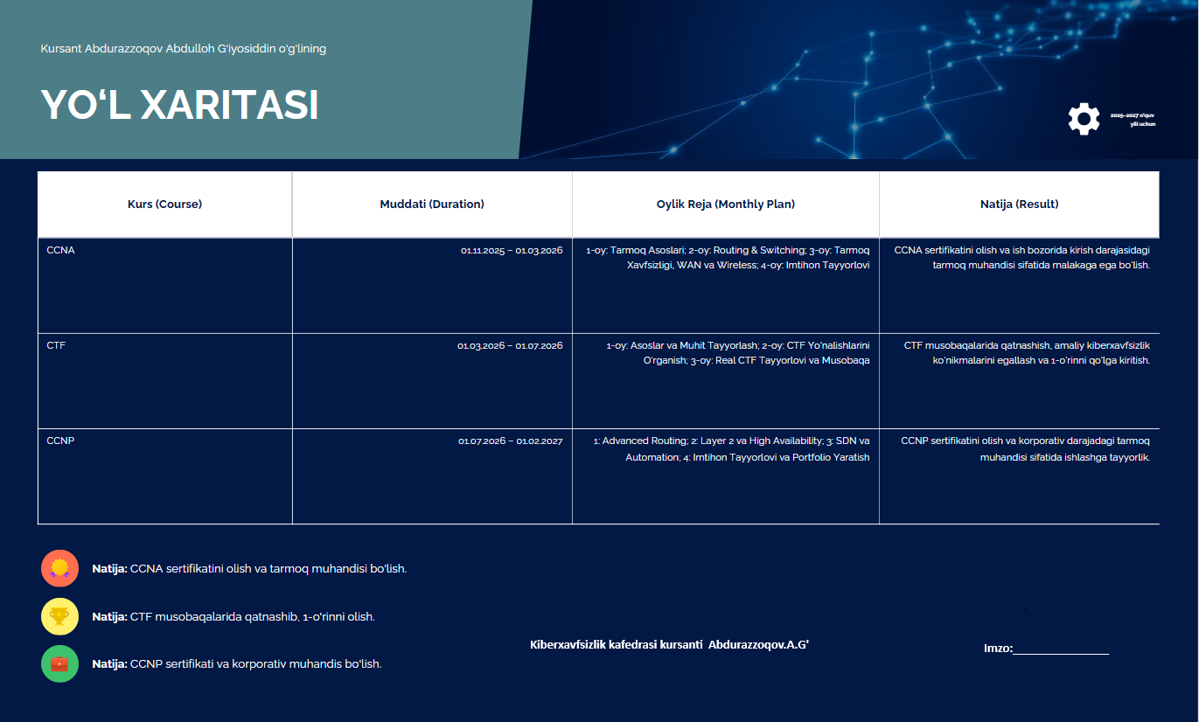
Image.png fayl ichidagi rasm
read_binary.py ichiga

with open("image.png", "rb") as f:
data = f.read() # butun faylni o‘qish
first_100 = data[:100] # birinchi 100 bayt
print(first_100)
with open("image_copy.png", "wb") as f_copy:
f_copy.write(data)
print("Fayl muvaffaqiyatli nusxalandi!")

shu kodlarni yozamiz.
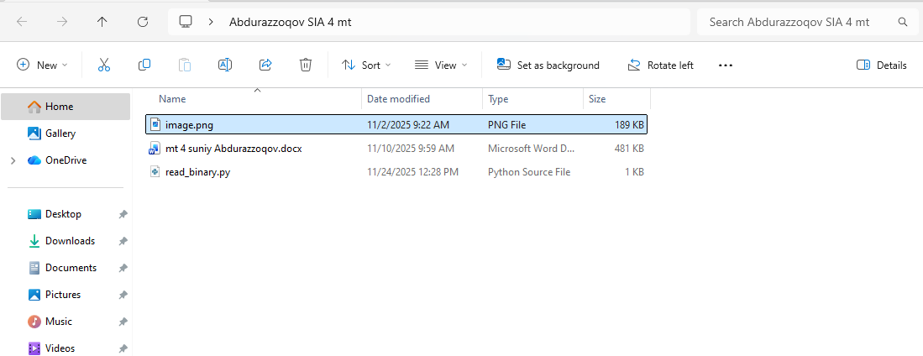
va read_binary.py ni ishga tushiramiz.
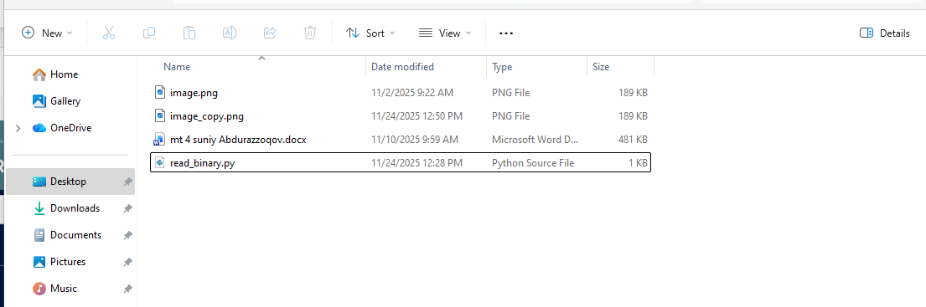
va yangi image_copy.png hosil bo’ladi.
2.
# Faylga to'liq manzil
file_path = r"C:\Users\abdurazzoqov_a\Desktop\Abdurazzoqov SIA 4 mt\log.txt"

# 1. Faylga qo'shimcha yozish
with open(file_path, "a", encoding="utf-8") as f: # To'liq manzil ishlatildi
f.write("YAngilangan ma'lumot\n")

# 2. Fayldan oxirgi yozuvni o'qish
try:
with open(file_path, "r", encoding="utf-8") as f: # To'liq manzil ishlatildi
lines = f.readlines()
if lines:
print("Oxirgi yozuv:", lines[-1].strip())
else:
print("Fayl bo'sh.")
except FileNotFoundError:
print(f"⚠️ Xatolik: {file_path} manzili topilmadi. Papka mavjudligini tekshiring.")

